Index

Exercise 1: Types 3

Task 1 - Create a TypeMinMax Project 3

Task 2 - Create a TypesMinMax class 3

Task 1 - Print MAX_VALUE and MIN_VALUE of each type 3

Task 2 - Execute your program 5

Exercise 2: Relational & Logical Operators 5

Task 1 - Create a RelationalLogicalOpTest Project 5

Task 2 - Create a RelationalLogicalOpTest class 5

Task 3 - Write your code 6

Task 4 - Execute your program 7

Exercise 3: Scanner object 7

Task 1 - Create a ScannerTest project 7

Task 2 - Create a ScannerTest class 7

Task 3 - Write your code 8

Task 4 - Execute your program 9

Exercise 4: If/else 9

Task 1 - Create a Mark project 9

Task 2 - Create a Mark class 9

Task 3 - Write your code 10

Task 4 - Execute your program 10

Exercise 5: Switch case 11

Task 1 - Create a Month project 11

Task 2 - Create a Month class 11

Task 3 - Write your code 11

Task 4 - Execute your program 12

Exercise 6: Arithmetic Operator 12

Task 1 - Create a Arithmetic Project 12

Task 2 - Create a Arithmetic class 12

Task 3 - Write your code inside the main() method 13

Task 4 - Execute your program 14

Exercise 7: Tax in New York City 14

Exercise 8: Pay for employee 14

Exercise 9: Warning messages 14

Exercise 10: Centimeters - inch 14

Exercise 11: Day of Week 15

**Next Step**

1. Types

Print the maximum, minimum and bit-length of the primitive types

## Create a TypesMinMax class

## Print MAX_VALUE and MIN_VALUE of each type

### Print Max value and Min value of int (32-bit signed integer)

* 1. System.*out*.println("int(min) = " + Integer.*MIN_VALUE*);
  2. System.*out*.println("int(max) = " + Integer.*MAX_VALUE*);
  3. System.*out*.println("int(bit-length) = " + Integer.*SIZE*);

### Print Max value and Min value of (8-bit signed integer)

* 1. System.*out*.println("byte(min) = " + Byte.*MIN_VALUE*);
  2. System.*out*.println("byte(max) = " + Byte.*MAX_VALUE*);
  3. System.*out*.println("byte(bit-length)=" + Byte.*SIZE*);

### Print Max value and Min value of short (16-bit signed integer)

* 1. System.*out*.println("short(min) = " + Short.*MIN_VALUE*);
  2. System.*out*.println("short(max) = " + Short.*MAX_VALUE*);
  3. System.*out*.println("short(bit-length) = " + Short.*SIZE*);

### Print Max value and Min value of long (64-bit signed integer)

* 1. System.*out*.println("long(min) = " + Long.*MIN_VALUE*);
  2. System.*out*.println("long(max) = " + Long.*MAX_VALUE*);
  3. System.*out*.println("long(bit-length) = " + Long.*SIZE*);

### Print Max value and Min value of char (16-bit character or 16-bit unsigned integer)

* 1. System.*out*.println("char(min) = " + (**int**)Character.*MIN_VALUE*);
  2. System.*out*.println("char(max) = " + (**int**)Character.*MAX_VALUE*);
  3. System.*out*.println("char(bit-length) = " + Character.*SIZE*);

### Print Max value and Min value of float (32-bit floating-point)

* 1. System.*out*.println("float(min) = " + Float.*MIN_VALUE*);
  2. System.*out*.println("float(max) = " + Float.*MAX_VALUE*);
  3. System.*out*.println("float(bit-length) = " + Float.*SIZE*);

### Print Max value and Min value of double (64-bit floating-point)

* 1. System.*out*.println("double(min) = " + Double.*MIN_VALUE*);
  2. System.*out*.println("double(max) = " + Double.*MAX_VALUE*);
  3. System.*out*.println("double(bit-length) = " + Double.*SIZE*);

## Execute your program

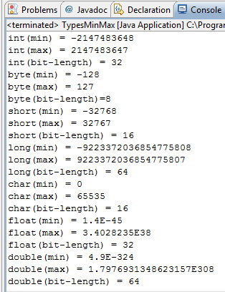

Relational & Logical Operators

## Create a RelationalLogicalOpTest class

### Declare and initialize variables

* 1. **int** age = 18;
  2. **double** weight = 71.23;
  3. **int** height = 191;
  4. **boolean** married = **false**;
  5. **boolean** attached = **false**;
  6. **char** gender = 'm';

### Test Relational & Logical Operators

* 1. System.*out*.println(!married && !attached && (gender == 'm'));
  2. System.*out*.println(married && (gender == 'f'));
  3. System.*out*.println((height >= 180) && (weight >= 65) && (weight <= 80));
  4. System.*out*.println((height >= 180) || (weight >= 90));

## Execute your program

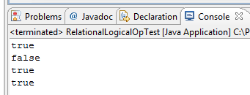

Scanner object

Write a program use Scanner Object to allow user input data from their keyboard.

## Create a ScannerTest class

### Import the Scanner Library

* 1. **import** java.util.Scanner;

### Construct a Scanner named "in" for scanning System.in (keyboard)

* 1. Scanner in = **new** Scanner(System.*in*);

### Use Scanner Object with its Method for user input

* Use nextInt() to read int
* Use nextDouble() to read double
* Use next() to read a String token, up to white space
  1. **int** num1;
  2. **double** num2;
  3. String str;
  5. System.*out*.print("Enter an integer: ");
  6. num1 = in.nextInt();
  7. System.*out*.print("Enter a floating point: ");
  8. num2 = in.nextDouble();
  9. System.*out*.print("Enter a string: ");
  10. str = in.next();

### Formatted output via printf()

* 1. System.*out*.printf("%s, Sum of %d & %.2f is %.2f\n", str, num1, num2, num1+num2);

## Execute your program

* 1. 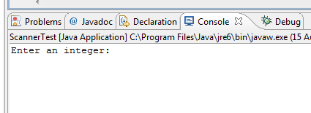
  2. Input the values and see the output

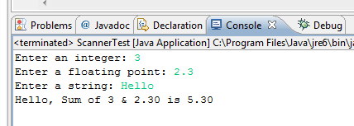

1. If/else

## Create a Mark class

**public** **class** Mark {

**public** **static** **void** main(String[] args) {

**int** testscore = 76;

**char** grade;

**if** (testscore >= 90) {

grade = 'A';

} **else** **if** (testscore >= 80) {

grade = 'B';

} **else** **if** (testscore >= 70) {

grade = 'C';

} **else** **if** (testscore >= 60) {

grade = 'D';

} **else** {

grade = 'F';

}

System.*out*.println("Grade = " + grade);

}

}

## Execute your program

* 1. 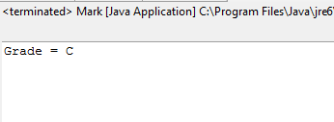

1. Switch case

## Create a Month class

**public** **class** Month {

**public** **static** **void** main(String[] args) {

System.*out*.print("Enter a month:");

Scanner scanner=**new** Scanner(System.*in*);

**int** month=scanner.nextInt();

String monthStrinhg;

**switch** (month) {

**case** 1: monthString = "January"; **break**;

**case** 2: monthString = "February"; **break**;

**case** 3: monthString = "March"; **break**;

**case** 4: monthString = "April"; **break**;

**case** 5: monthString = "May"; **break**;

**case** 6: monthString = "June"; **break**;

**case** 7: monthString = "July"; **break**;

**case** 8: monthString = "August"; **break**;

**case** 9: monthString = "September"; **break**;

**case** 10: monthString = "October"; **break**;

**case** 11: monthString = "November"; **break**;

**case** 12: monthString = "December"; **break**;

**default**: monthString = "Invalid month"; **break**;

}

System.*out*.println(monthString);

}

}

## Execute your program

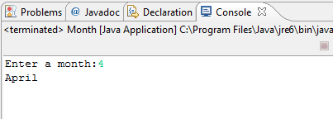

1. Tax in New York City

Sales tax in New York City is 8.25%. Write a program that accepts a price and prints out the appropriate tax and total purchase price.

1. Pay for employee

Write a program that reads two numbers, the number of hours worked by an employee and their base pay rate. Then output the total pay due.

1. Warning messages

Add warning messages to the payroll program if the pay rate is less than the minimum wage ($5.15 an hour as of 1998) or if the employee worked more than the number of hours in a week.

1. Centimeters - inch

There are exactly 2.54 centimeters to an inch.

Write a program that takes a number of inches and converts it to centimeters.

Write the inverse program that reads a number of centimeters and converts it to inches.

1. Day of Week

Write a program to accept a day of week and print it to screen like that:

1🡪 print: Monday

2 🡪 print: Tuesday

...

7-> print: Sunday